각 가정에서 경험할 수 있는 QR 코드입니다.
아이원더 잉글리쉬와 함께 즐거운 시간을 보내보세요!
Vol.6 QR Code
Pre-K
Story | Song | Phonics 1 | Phonics 2 |  | Phonics 3
Mr. Geneus | Mr. Geneus | Where is K? | Where is L? |  | Where is M?
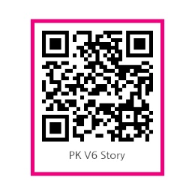 | 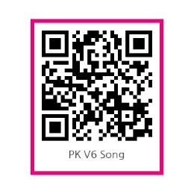 | 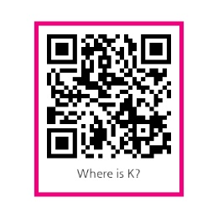 | 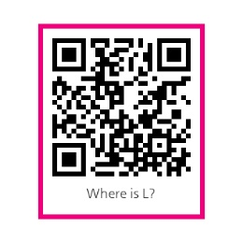 |  | 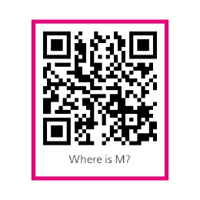
K1
Story | Song | Phonics 1 | Phonics 2 |  | Phonics 3
Funny Turkey | Funny Turkey | Big K Little k | Big L Little l |  | Big M Little m
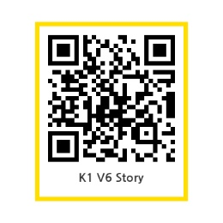 | 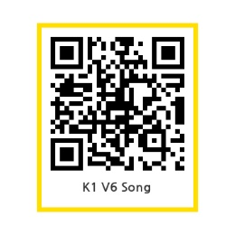 | 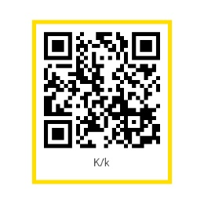 | 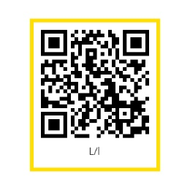 |  | 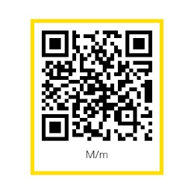
K2
Story | Song | Phonics 1 | Phonics 2 |  | Phonics 3
Today Is Monday | Today Is Monday | K says /k/ | L says /l/ |  | M says /m/
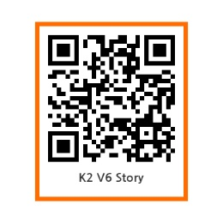 | 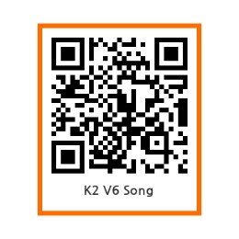 | 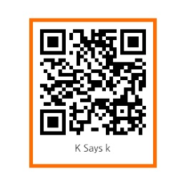 | 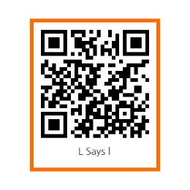 |  | 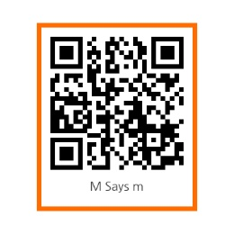
K3
Story | Song | Phonics 1 |  | Phonics 2
Autumn Festival | Autumn Festival | Long a |  | Celebration:  we, get
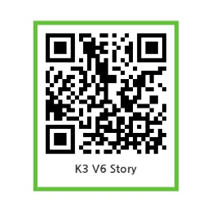 | 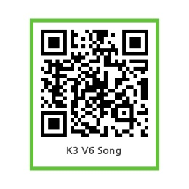 | 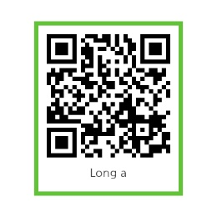 |  | 

